Doctoral Occupational Therapy Capstone Report

Madeline Fletcher
Department of Occupational Therapy, Xavier University
OCTD 802: Capstone Scholarship
Dr. Leah Dunn
11/24/2025

Table of Contents
Introduction to the Doctoral Capstone 5
Doctoral Capstone Title 5
Purpose of the Capstone Project 5
Theoretical Models 5
Content Area 6
Scholarship Type 6
Capstone Relationship to Mission and Philosophy 7
Xavier University Mission 7
Department of Occupational Therapy Mission 7
Department of Occupational Therapy Philosophy 7
Relationship 7
Capstone Development Part I 9
Capstone Site 9
Literature Review and Needs Assessment 10
Literature Review 10
Needs Assessment 10
Capstone Development Part II 11
Capstone Proposal 11
Capstone Goals and Objectives 11
Capstone Project Plan 11
Capstone Evaluation 11
Capstone Memorandum of Understanding 11
Capstone Implementation and Results 13
Activity 1 13
Description of the Participants 13
Implementation/Methodology 13
Results 14
Activity 2 15
Description of the Participants 15
Implementation/Methodology 16
Results 17
Activity 3 Error! Bookmark not defined.
Description of the Participants Error! Bookmark not defined.
Implementation/Methodology Error! Bookmark not defined.
Results Error! Bookmark not defined.
Capstone Discussion 21
Evaluation of the Captone Project (Activity 1) and Correlation with Literature 21
Recommendations for Practice, Policy, and/or Education Error! Bookmark not defined.
Evaluation of the Captone Project (Activity 2) and Correlation with Literature 21
Recommendations for Practice, Policy, and/or Education Error! Bookmark not defined.
Evaluation of the Captone Project (Activity 3) and Correlation with Literature Error! Bookmark not defined.
Recommendations for Practice, Policy, and/or Education Error! Bookmark not defined.
Reflection of the Capstone 23
Reflective Synthesis/ Creative Epilogue 24
Appendix A: Literature Table 25
Appendix B: Scoping Review 31
Appendix C: IRB Application 37
Appendix E: Capstone Goals and Objectives for a Capstone Project Table and a Capstone Experience Table 49
Appendix F: Signed Memorandum of Understanding 52
Appendix G: IRB Letter of Response 56
Appendix H: Week-by-Week Project Plan 57

INSERT STATEMENT HERE

Madeline Fletcher 11/24/25
_____________________________________________ _____________________
Student Date
_____________________________________________ ___________________
Capstone Coordinator Date
_____________________________________________ ___________________
Faculty Mentor Date
_____________________________________________ ___________________
Capstone Site Date

Introduction to the Doctoral Capstone
The doctoral capstone is a culminating project and experience for doctoral capstone students that occurs after all clinical and didactic courses are completed. The evidence-based project requires the student to relate theory to practice, synthesizing in-depth knowledge in a specific practice area. The experience provides an in-depth exposure to a concentration area. Throughout the project and experience, the student is mentored by the capstone site (recipient), the Xavier University Faculty Mentor, and the Doctoral Capstone Coordinator.

This capstone proposal section contains the capstone title, purpose, theoretical models used, content area, type of scholarship, and the relationship to the Xavier University Mission and the Department of Occupational Therapy Mission and Philosophy.

Doctoral Capstone Title
Feeding Knowledge, Fueling Confidence: Instructional Strategies in Pediatric Occupational Therapy Education

Purpose of the Capstone Project

This capstone project aims to evaluate and compare the perceived confidence and competence of occupational therapists following different educational delivery methods during a pediatric feeding lab, including an educational simulation video or standard instructional methods. Additionally, educational videos of feeding interventions were created to increase the standardization of education and confidence of onboarding occupational therapists undergoing a feeding competency. This specific capstone project of examining instructional methods in education is being completed to provide a more comprehensive and effective learning experience for occupational therapy students and onboarding occupational therapists.

Theoretical Models
Below is a brief description of the conceptual or theoretical models used to frame this capstone project and how it was applied.

The use of adult learning theory in this capstone project is essential because it aligns with the unique learning needs, motivations, and experiences of occupational therapists participating in pediatric feeding education. Adult learning theory emphasizes self-direction, relevance, and the application of prior knowledge, which are key components for practicing clinicians who must integrate new skills into existing professional frameworks. By comparing different instructional methods, such as simulation-based educational videos and traditional teaching approaches, the project recognizes that adult learners benefit most from learning experiences that are immediately applicable to their clinical roles. This theory supports the idea that adults learn more effectively when they understand the purpose behind the content, can connect it to real-world practice, and actively engage in the learning process.
Additionally, the adult learning theory justifies the creation of standardized educational videos to enhance competence and confidence in occupational therapists completing feeding competencies. The theory highlights that adults prefer learning that is accessible, flexible, and reflective of real clinical scenarios, elements that high-quality simulation videos can provide more consistently than variable in-person instruction. By applying adult learning principles, the project aims to create a more meaningful, efficient, and impactful educational experience for both occupational therapy students and onboarding clinicians. This ensures that instructional methods not only transfer knowledge but also strengthen clinical reasoning and preparedness, ultimately improving the quality of pediatric feeding interventions delivered in practice.

Content Area
The goal of the doctoral capstone is to provide students with an in-depth exposure to one or more of the content areas. These include: clinical skills, research skills, program development and assessment, policy development, advocacy, education, and leadership. Students select a primary and secondary content area.

The primary content area consists of the core content area of education, as it
focuses on developing and evaluating effective teaching methods to enhance clinical skill acquisition among occupational therapists. By comparing simulation-based and standard instructional approaches, the project contributes to evidence-based strategies for improving therapist training and professional competency. The creation of standardized educational videos also supports ongoing learning and consistency in clinical education for onboarding occupational therapists.

Additionally, program development is utilized as a secondary content area, leveraging educational videos as a tool to enhance the consistency and quality of content provided in the feeding competency program at Cincinnati Children’s Hospital. Through evaluating the effectiveness of instructional strategies for occupational therapy students, the project also contributes to the ongoing improvement and sustainability of occupational therapy doctoral programs.

Scholarship Type
Student capstone projects are considered scholarly studies. The project represents one of the four types of scholarship: (1) scholarship of discovery, (2) scholarship of application, (3) scholarship of teaching and learning.

All activities completed in this capstone represent the scholarship of teaching and learning by focusing on how educational strategies can enhance professional competence and confidence among occupational therapy students and onboarding occupational therapists. It investigates the impact of different instructional methods—specifically simulation videos versus traditional teaching—on skill development in pediatric feeding interventions. Additionally, the project seeks to identify approaches to learning that improve outcomes and clinical readiness of students and therapists. The creation of standardized educational videos demonstrates the application of teaching outside of a classroom to promote consistency and effectiveness in therapist training. By evaluating the learning experiences and perceptions of occupational therapists, the project contributes valuable insights to the field of occupational therapy education. Overall, this capstone exemplifies the integration of research, educational strategies, and clinical application to advance teaching and learning within the profession of occupational therapy.

Capstone Relationship to Mission and Philosophy
The doctoral capstone is related to the Xavier University Mission and the Department of Occupational Therapy Mission and Philosophy.

Xavier University Mission
Xavier is a Jesuit Catholic university rooted in the liberal arts tradition. Our mission is to educate each student intellectually, morally and spiritually. We create learning opportunities through rigorous academic and professional programs integrated with co-curricular engagement. In an inclusive environment of open and free inquiry, we prepare students for a world that is increasingly diverse, complex and interdependent. Driven by our commitment to educating the whole person, promoting the common good, and serving others, the Xavier community challenges and supports all our members as we cultivate lives of reflection, compassion and informed action.

Department of Occupational Therapy Mission
Our Mission is to educate and prepare future occupational therapists who respond to the occupational needs of a diverse, complex, interdependent, and ever-changing global society. Xavier University OTD graduates will practice as ethical, competent, and caring professionals using critical, creative, and reflective thinking and habits of lifelong learning. As professionals, Xavier University graduates will balance autonomous and collaborative decision-making to successfully navigate a variety of inclusive delivery systems in traditional and emerging practice areas where they implement theory-driven and evidence-based practice. Xavier University graduates will be leaders who model and advocate for justice for persons, groups, and populations. To promote occupational participation and advance the profession, our graduates will utilize, produce, and disseminate scholarly works.

Department of Occupational Therapy Philosophy
We believe:
- Humans are biopsychosocial beings who are transformed by participation in occupation.
- Participation in meaningful occupations shapes human lives and is intrinsically connected to one’s health and well-being.
- As members of intra- and inter-professional teams, occupational therapists form a dynamic and collaborative relationship with people, populations, and communities to maximize occupational participation and realize occupational potential.
- Best practice in occupational therapy is client-centered, occupation-based, theory-driven, evidence-based, and grounded in sound ethical principles.
- Students learn best through independent exploration coupled with active engagement in authentic and learner-centered learning experiences and self-reflection.

Relationship
Below is a description of the relationship between the doctoral capstone and the mission of the Xavier University and the mission and philosophy of the Department of Occupational Therapy meeting ACOTE standard D.1.3).
This capstone project connects to the mission of Xavier University and its commitment to transformative education by fostering learning experiences that enhance professional growth and clinical competence among new occupational therapists and occupational therapy students. It also reflects the mission of Xavier University’s Occupational Therapy Doctoral Program, which emphasizes lifelong learning and professional development, as the project supports continued competency growth for therapists beyond graduation. Through the creation and implementation of standardized educational videos, this project demonstrates leadership and advocacy by actively contributing to the improvement of clinical competence among current and future practitioners. The educational materials also promote social responsibility and service to diverse communities by fostering a deeper understanding of how to provide effective, culturally responsive feeding interventions. Additionally, the capstone supports ethical and compassionate practice by emphasizing client-centered care and evidence-based approaches that uphold the values of the occupational therapy profession.

Capstone Development Part I

Part I of the capstone development includes a literature review, site interview, and needs assessment. These form the foundation of the capstone project described in the following section of this proposal. This section provides documented evidence of ACOTE standard D.1.3, which states that “the doctoral capstone is an integral part of the program’s curriculum design’ and reflects the mission and philosophy of the program, contributes to the development of in-depth knowledge in a designated area of interest, and includes preparation consisting of a literature review and needs assessment” (ACOTE, 2023)

Capstone Site
The capstone site is the organization with which the student partners to complete the project and experience. The site is selected in collaboration with the student, doctoral capstone coordinator, and the faculty mentor.

The site chosen for the completion of this doctoral capstone is Cincinnati Children’s Hospital. Cincinnati Children’s Hospital Medical Center (CCHMC) is a leading pediatric academic medical center located in Cincinnati, Ohio. It is internationally recognized for its excellence in clinical care, research, and education focused exclusively on pediatrics, as well as consistently ranked among the top children’s hospitals in the United States. The mission of the organization includes emphasizing improving child health and transforming care delivery through innovation, compassionate service, and community engagement, with an overall vision to be a leader in improving the health of children.

Cincinnati Children’s Hospital offers a variety of pediatric services, ranging from primary care to the most advanced specialty and surgical treatments. Nearly every area of child health is covered, providing specialized care in areas such as cancer, cardiology, neonatology, gastroenterology, and orthopedics. The hospital also provides inpatient, outpatient, and emergency care, along with specialized rehabilitation programs, including occupational therapy.

The Occupational Therapy Department at Cincinnati Children’s Hospital provides comprehensive, family-centered care to help children develop the skills needed for daily activities, play, and independence. Therapists work with patients of all ages and diagnoses using evidence-based interventions to enhance motor, sensory, and self-care abilities. The department also collaborates closely with other specialties in multidisciplinary teams to support each child’s overall growth and participation in the hospital, at home, school, and in the community.

Literature Review and Needs Assessment

Literature Review
The doctoral capstone literature review was conducted in OCTD 604 (See Appendix A: Literature Table), OCTD 633 (See Appendix B: Scoping Review), and OCTD 705 (See Appendix C: IRB Application Problem Statement).

Needs Assessment
Needs Assessment for the doctoral capstone was completed in OCTD 604 in collaboration with the student, faculty mentor, and doctoral capstone coordinator and was used as the foundation for this doctoral capstone. The Needs Assessment contains parts: (1) review of the literature, (2) description of the problem, and (3) site interview. See Appendix D: Needs Assessment.

Capstone Development Part II

The section contains the doctoral capstone proposal, which includes the goals and objectives, week-by-week project plan, and capstone evaluation plan. This section contains evidence that the doctoral capstone was “designed through collaboration with the student, a faculty member in the occupational therapy educational program who holds a doctoral degree, and an individual with documented expertise in the content area of the capstone” (ACOTE D.1.1, 2023), contains “goals/objectives, and a plan to evaluate project outcomes” (ACOTE, D.1.3), and that the site mentor (content expert) was “informed of the plan for and purpose of the doctoral capstone” (ACOTE D.1.2).

Capstone Proposal

Capstone Goals and Objectives
Goals and objectives are defined for both the capstone (1) project and (2) experience. The goals describe what the capstone student will learn or do, while the objectives define how this will be accomplished. Each goal and objective is listed with the proposed evidence of achievement for each. There is one table for the capstone project goals and objectives, and a separate table for the capstone experience. See Appendix E: Capstone Goals and Objectives for a Capstone Project Table and a Capstone Experience Table.

The doctoral capstone experience learning goals and objectives, as well as the project goals and objectives, were collaboratively developed by the student, faculty mentor, and doctoral capstone coordinator. All goals and objectives were reviewed with the site mentor. Evidence of this is provided in the site mentor-signed Memorandum of Understanding, which contains the individual student goals and objectives. See Appendix F: Signed Memorandum of Understanding.

Capstone Project Plan
The capstone project plan consists of a Week-by-Week Project Plan and the procedures section of the IRB Application. Each was collaboratively developed by the student, faculty mentor, capstone site mentor, and doctoral capstone coordinator. See Appendix C: IRB Application and Appendix G: IRB Letter for the Response to the IRB Application. See Appendix H: Week-by-Week Table for the planned capstone activities by week.

Capstone Evaluation
The capstone evaluation is determined by assessing the student’s ability to meet their capstone goals and objectives. The capstone evaluation is divided into two sections: (1) project and (2) experience and is completed at mid-term (approximately week 7) and again at week 14 (final). The mid-term and final capstone evaluations are completed and maintained on EXXAT/Prism.

Capstone Memorandum of Understanding
A capstone Memorandum of Understanding (MOU) is executed prior to the start of the doctoral capstone and contains the roles and responsibilities of all parties, plans for evaluation, mentoring and supervision (ACOTE, 2023, D.1.4). See Appendix F: Signed Memorandum of Understanding.

Capstone Implementation and Results

This section contains a description of the implementation of the capstone project, results, summary, and reflection. This section is completed during OCTD 802: Capstone Scholarship.

Activity 1
Educational Intervention Demonstration Videos for Onboarding Therapists
This project consisted of the creation of educational videos of feeding interventions to increase the standardization of education and confidence of onboarding occupational therapists undergoing a feeding competency.

Description of the Participants

The participants viewing the videos consist of onboarding occupational therapists completing the feeding competency at Cincinnati Children’s Hospital. Once an occupational therapist is hired, the onboarding and training process takes around three months to complete. During that time, onboarding therapists are required to complete three competencies for more specialized areas of therapy, including feeding. The feeding competency program is completed over a six-week period, during which therapists are required to accumulate a minimum of sixty hours of feeding treatment and complete all designated educational modules. While four therapists completed the competency during the capstone project, the videos will be accessed by all onboarding therapists in the future.

Implementation/Methodology
An IRB was not required for the completion of this activity at Cincinnati Children’s Hospital due to the program evaluation nature of the project. To determine the content of the educational videos being made, a needs assessment was conducted with the six occupational therapists included on the intradisciplinary feeding team. The following areas were addressed as desired content for onboarding occupational therapists to be educated on:
- Infant bottle-feeding cues
- Sensory interventions
- Food chaining
- Transition to purees
- Transition to solids
- Mealtime behaviors
- Oral motor interventions and tools
- Autism feeding interventions
- Strider
- Dysphagia

Following the needs assessment and determination of content areas provided in the videos, the schedules of occupational therapy feeding team members were analyzed to determine possible patients to film for the educational videos. During treatment sessions prior to recording, parents and guardians were asked permission to film and were required to sign a consent form agreeing to the video for internal use by hospital employees only. The session was then videotaped on a camcorder for the entirety of the feeding intervention, ranging from 15-45 minutes of feeding content. Videos of the treatment session were downloaded from the camcorder onto a flash drive. The videos were edited on a Mac computer in the iMovie application, allowing for videos to be clipped to be applicable for the onboarding therapists.

Modifications
Modifications for the activity were required due to the HIPAA and electronic protocols at Cincinnati Children's Hospital. Instead of recording the videos with an iPad, the videos were recorded with a hospital camcorder and shared through a USB drive due to limited access to Microsoft Teams for capstone students to share or have access to the videos. Additionally, a study was initially planned to assess onboarding therapists’ feeding competency before and after viewing the educational videos. However, these modifications could not be implemented, as obtaining IRB approval through Cincinnati Children's Hospital would have required an extended review period.

Results
A total of 45 videos were created for this project. Twenty-seven videos consisted of edited videos of the feeding intervention during treatment sessions. The edited videos range from one and a half minutes to six minutes long, allowing for a variety of treatments to be seen. For easy therapist access, the videos were saved in two different folders titled “Patients over one year” and “Patients under one year”. Within these folders, the videos were organized by the intervention provided in the videos. There were sixteen videos with patients over the age of one, with videos focused on food exploration, food chaining, evaluation of eating, anxiety with food, sensory interventions, mealtime behaviors, and oral motor interventions. There were also eleven videos with patients under the age of one year, including videos focused on infants in the NICU, transition to solids, transition to purees, strider, pacing with bottle feeding, and infant cues with bottle feeding.

In addition to these videos, eighteen videos were retrieved from the children of the occupational therapists on the feeding team. These videos were edited and will be used for educational purposes to demonstrate typical feeding patterns and behaviors for specific developmental ages. A flow chart was created to view the different educational videos created below (Figure 1: Educational Videos Flow Chart). In addition to the edited videos, all full treatment videos were placed in a folder on the flash drive to keep for future use within the occupational therapy department at Cincinnati Children’s Hospital Medical Center.

Figure 1.

Educational Videos Flow Chart

Activity 2
Comparing Instructional Methods for Teaching the IDDSI Framework in an Occupational Therapy Feeding Lab
This study examined the effectiveness of two instructional methods, educational simulation videos and traditional materials, in teaching the International Dysphagia Diet Standardization Initiative (IDDSI) assessment during a pediatric feeding lab for second-year occupational therapy doctorate students. Using a two-group, post-only comparison design, participants completed hands-on practice following their assigned instructional approach and later responded to an anonymous survey assessing their learning experience, perceived competence, and confidence in administering the IDDSI assessment. Quantitative Likert-scale data and qualitative feedback were analyzed to compare the impact of instructional strategies on student engagement and IDDSI knowledge.

Description of the Participants
Participants in the study are second-year occupational therapy doctorate students at Xavier University, who are completing the feeding labs in the pediatrics course. These participants were selected based on convenience sampling. Out of the twenty-three students in the second-year cohort for occupational therapy students completing the lab, twenty-two students completed the survey. Due to the large size of the class, the pediatric lab was divided into two sections. The flow chart below represents the participants enrolled in the research study.

Figure 2.
Participant Recruitment

Implementation/Methodology
This study used a two-group post-only comparison and was deemed exempt by the university’s institutional review board. The study was implemented during the two feeding labs in the pediatrics course for second-year occupational therapy doctorate students at Xavier University. Prior to the lab, the participants were made aware of the study through a faculty advisor at Xavier University who read the recruitment script and answered any questions.
The feeding lab consisted of a 110-minute educational session with eight stations focusing on various feeding concepts and interventions. One station was focused on the International Dysphagia Diet Standardization Initiative (IDDSI) Framework. The IDDSI is an assessment used for providing a standardized approach to assess solid and liquid food textures. During this lab station, each lab section received an initial instructional strategy for the IDDSI assessment, including an educational simulation video or traditional instruction on the IDDSI Flow Test, which assesses the thickness of liquids. A coin was flipped to determine the educational approach for the first lab, which was the educational videos, with the traditional instructional methods approach (PDF handout) for the second lab. Once the instructional strategy was provided, the participants had time to trial the assessment that they learned with hands-on experience.
Following the completion of the pediatric feeding lab, a QR code was provided for access to an anonymous survey in Qualtrics. The survey was created to evaluate the learning experience for each lab group and to examine and compare their experience with each instructional method. Participants provided informed consent with their response to the first question of the survey. In the survey, participants were asked to answer questions based on a Likert scale on topics including their view on videos as an educational tool, knowledge of IDDSI before and after the lab, and their confidence and competence after the session. Participants were provided with the opportunity to share their feedback on their experience with the lab. Out of the 23 students in the second-year cohort who participated in the lab, 22 students completed the survey, with 10 students in Lab A and 12 students in Lab B.

Modifications
A modification that was made to the study includes the content in the IDDSI lab station. Due to the variety of stations that students were required to attend in the lab, limited time was provided at the IDDSI station. This resulted in reducing the amount of educational video shown and the explanation provided with the handout that the students were able to view.

Results
The data from the two-group post-only surveys were entered and compared using the Statistical Package for the Social Sciences Software (SPSS) and Microsoft Excel. A two-sample Mann-Whitney U Test was conducted using the retrieved ordinal data to compare the results from the labs. The results indicated that there was no significant difference between the educational video provided in of Lab A and the standard educational handout provided in Lab 2, U = 15, z = 0.4039, p= 0.6863.

Because all questions were scored using a Likert scale ranging from strongly disagree (1) to strongly agree (5), results indicate that all participants reported a positive experience in the IDDSI lab. Participants in Lab A (video), which included the educational video, demonstrated a slightly higher level of agreement regarding their overall experience, with an average score of 4.54 compared to 4.3 in Lab B (traditional). Conversely, participants in Lab B rated educational videos as a more effective learning tool than those in Lab A, with Lab B reporting an average score of 4.54 and Lab A an average of 4.3 (Figure 3: Learning Experience with IDDSI Lab).

Figure 3.
Learning Experience with IDDSI Lab

For the competence measure for before and after the IDDSI lab station, possible scores ranged from a very low level of knowledge (1) to a very high level of knowledge (5). Prior to the feeding lab, participants in both groups demonstrated low levels of competence in IDDSI assessment, with Lab A(video) reporting a slightly higher average score of 1.5 compared to 1.3 in Lab B(traditional). Following the instructional content provided during the feeding lab, both groups showed notable improvements in their self-perceived competence levels. Lab A demonstrated an average post-lab score of 3.8, reflecting a total increase of 2.3 points, while Lab B demonstrated an average post-lab score of 3.4, reflecting a total increase of 2.1 points (Figure 4: IDDSI Competence Before and After Feeding Lab)

Figure 4
IDDSI Competence Before and After Feeding Lab

For the confidence measure after the IDDSI lab station, possible scores ranged from a very low level of confidence (1) to a very high level of confidence (5). Lab A (video) had an average of 3.8, indicating that the participants had a high level of confidence in performing the IDDSI assessment after receiving the educational video as the primary instructional method. Lab B (traditional) had an average of 3.4, indicating the participants were somewhat confident in administering the IDDSI assessment following the standard educational method as the primary instructional method (Figure 5: Confidence Levels Performing IDDSI After Lab).

Figure 5.
Confidence Levels Performing IDDSI After Lab

For the satisfaction measure after the IDDSI lab station, possible scores ranged from a very low level of satisfaction (1) to a very high level of satisfaction (5). Both labs demonstrated a very high level of satisfaction, with Lab A (video) having an average of 4.8 and Lab B (traditional) with an average of 4.5 (See Figure 6: Satisfaction Levels After Lab)

Figure 6.
Satisfaction Levels After Lab

A thematic analysis was conducted to evaluate the qualitative feedback regarding participants’ lab experiences and the instructional methods used. In Lab A (video), three participants indicated that the educational video provided at the lab station was helpful. Additional comments included a desire for a greater variety of foods and textures during the IDDSI assessment, as well as positive remarks about the hands-on experience of modifying texture thickness using the IDDSI flow test. In Lab B (traditional), four participants reported that they appreciated the standard educational materials and the in-person verbal instruction. Conversely, one participant expressed a preference for having access to a video demonstration of the assessment. Feedback related to other aspects of the lab in Lab B included enjoyment of tasting thickened liquids and a request for additional time at the lab station.

Capstone Discussion

The discussion section contains an interpretation of the results and explains their significance. This can include a connection to the broader context, evaluation of the significance, acknowledgement of limitations, and proposed future direction of research or unanswered questions.

Activity 1

Evaluation of the Captone Project and Correlation with Literature
The collected videos form a comprehensive and well-organized educational library that enhances clinical training in feeding interventions. The diversity of edited clinical videos provides practical examples of a wide range of feeding challenges and treatment strategies. Additionally, the inclusion of videos showing typical developmental feeding patterns allows for clear comparison between typical and atypical behaviors. The structured folder system enhances accessibility and usability, ensuring the resource can support onboarding of therapist education for feeding competency and future departmental training needs. Overall, the project successfully created a valuable, long-term tool for advancing the feeding competency within the occupational therapy department.

Recommendations for Practice, Policy and/or Education

For clinical practice, the video collection can be integrated into onboarding competency training and ongoing professional development to promote consistent, high-quality feeding intervention skills. The inclusion of both typical and atypical feeding examples enhances clinical reasoning by helping therapists recognize developmental patterns and feeding challenges more effectively. At the policy level, the video resources demonstrate the value of standardized feeding competency requirements by increasing observation of treatment sessions. Additionally, the videos highlight the need for organizational support and dedicated time for multimedia training tools. Such structured educational materials can help ensure uniformity in onboarding clinician preparation across healthcare settings. For occupational therapy education, incorporating intervention videos into the academic curriculum can strengthen students’ understanding of feeding development and intervention strategies. The organized video library also offers a reliable supplementary resource that supports competency-based education and better prepares students for clinical practice.

Activity 2

Evaluation of the Captone Project and Correlation with Literature
Comparing both instructional methods used found to be effective in improving participants’ competence and confidence in performing the IDDSI assessment. However, the Mann-Whitney test showed no statistically significant difference between the two groups (U = 15, p = 0.6863). This suggests there is minimal difference between the two lab sections, indicating that there is not enough statistical evidence to prove a difference in students' confidence and competence with educational videos. Still, the survey data revealed several meaningful trends.
Participants in both labs demonstrated substantial increases in competence from pre- to post-lab, confirming that the IDDSI lab itself was successful in enhancing learners’ understanding of IDDSI procedures. Lab A, which received the video-based instruction, showed slightly greater gains in competence, higher confidence ratings, and higher satisfaction scores. These findings suggest that while the video did not produce statistically significant differences, it may offer practical benefits that improve the learning experience. The thematic analysis of qualitative feedback supports this interpretation. Participants in Lab A frequently described the video as helpful, while some participants in Lab B expressed a desire for a video demonstration.
Both groups valued the hands-on elements of the lab and suggested improvements such as more food options and additional time at the station, increasing the effectiveness of the pediatric feeding lab in the future. Overall, the results suggest that both instructional approaches are effective, but integrating an educational video may enhance learner engagement, perceived understanding, and confidence, even if the measurable differences are small and not statistically significant. Additionally, it suggests a multi-modal approach to be beneficial, including the use of a variety of instructional methods in educational settings such as videos, handouts, PowerPoint slides, and hands-on learning experiences.

Recommendations for Practice, Policy and/or Education

For occupational therapy practice, a blended instructional model that combines video resources, in-person guidance, and hands-on practice is recommended to strengthen onboarding clinician preparedness. Maintaining a repository of instructional and clinical videos and expanding opportunities for learners to work with a wider variety of food textures may further enhance clinical skill development for occupational therapists performing feeding interventions. Viewing occupational therapy in action leads to a deeper understanding, rather than relying solely on case studies to increase competency. At the policy and organizational level, the results highlight the importance of standardized IDDSI and other feeding training across healthcare settings. Institutions may consider implementing routine competency assessments and supporting the development of high-quality educational materials through appropriate funding and resource allocation. For occupational therapy education, incorporating video-based instruction into coursework, increasing hands-on lab time, and using both typical and atypical feeding examples can deepen students’ clinical reasoning and assessment skills. Competency-based evaluations are also encouraged to ensure graduates are prepared for real-world feeding and swallowing assessment demands. Additionally, the findings suggest that structured, multimodal instructional approaches can meaningfully enhance learning outcomes in education within occupational therapy.

Reflection of the Capstone

During my capstone experience, I gained the knowledge I anticipated and significantly more. Assisting in the pediatric feeding lab enhanced my understanding of feeding interventions, as teaching the material to others required a high level of competence with the IDDSI assessment. This role also strengthened my confidence, communication abilities, and professionalism, further preparing me for occupational therapy practice as a practitioner. Filming the educational treatment videos provided additional in-depth learning, as it afforded extensive exposure to a wide range of feeding treatment sessions. I had the opportunity to observe and assist with interventions across multiple clinical settings, including outpatient services, inpatient rehabilitation, acute care, and the NICU, with interdisciplinary feeding teams. These experiences broadened my understanding of pediatric feeding by allowing me to work with children of diverse ages and diagnoses, observe varying clinical approaches, and better appreciate the complexity of individualized treatment planning.

An unanticipated but highly valuable component of my capstone experience was attending a two-day feeding conference at Cincinnati Children’s Hospital. Presentations from clinicians and healthcare professionals addressed common diagnoses associated with feeding difficulties and highlighted current research and evidence-based practices. This experience deepened my understanding of occupational therapy’s role in pediatric feeding and further advanced my clinical competence and skills.

Reflective Synthesis/ Creative Epilogue

This section contains a reflection of the doctoral capstone, including both the capstone experience and project. Students create an individual reflective synthesis of the capstone in a format of their choice. This includes, but is not limited to: narrative, video, website, artwork, poem, or song.

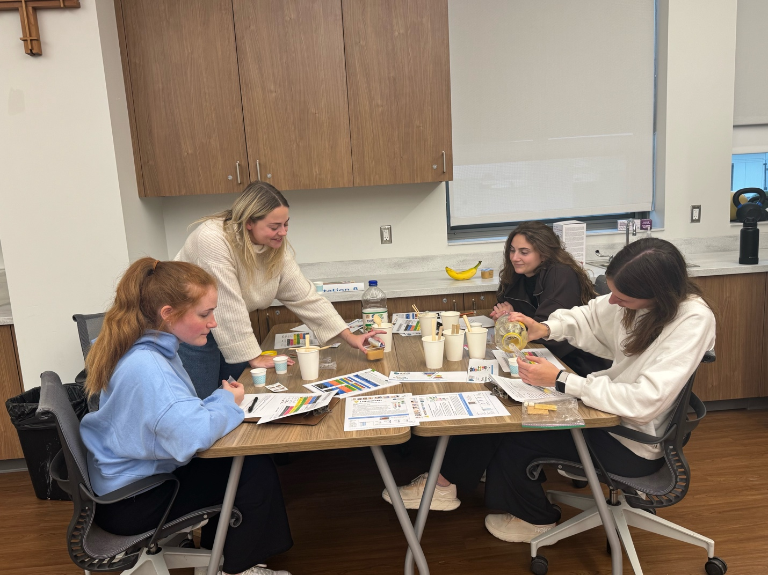
Gathered around the table, each of us immersed in measuring, mixing, planning, and problem-solving, this moment captures the heart of my capstone experience. What appears to be a simple lab setup actually represents weeks of collaboration, exploration, and hands-on learning. Through experiences like this, I deepened my understanding of feeding interventions and witnessed just how meaningful occupational therapy focused on feeding can be for children and their families. The cluttered workspace, including the inevitable mess, reflects the real, imperfect, and rewarding work that goes into helping children progress toward their feeding goals.
As I shared ideas, tested strategies, and supported the students, I could feel my confidence growing and increasing, as it did throughout the capstone experience. This photo is more than a snapshot of a project; it is a visual reminder of the personal and professional growth that occurred over sixteen weeks. It shows that development doesn’t happen only in clinics or hospital rooms, as it also happens in moments of collaboration, curiosity, and engagement. This experience has helped shape the occupational therapist I am becoming, and I’m excited for what the future holds in my professional career.

Appendix A: Literature Table

APA Reference | Research Design | Participants  (who and how many) | Type of data collected (interview likert, WHOQAL) | Tools | Results | Limitations | Comments
Aydon, L., Hauck, Y., Murdoch, J., Siu, D., Sharp, M. (2018). Transition from hospital to home: Parents’ perception of their aration and readiness for discharge with their preterm infant. Journal of Clinical Nursing, 27: 269–277. https://doi.org/10.1111/jocn.13883 | Qualitative descriptive Design; Level 2 | 20 couples (40 parents) | Pre-discharge interview and 4-6 weeks post-discharge interviews with open-ended questions that could be done face to face, over the phone, or online | Open-ended interview guide | Three themes were found between all of the post-discharge interviews. These were feeling involved and informed, being prepared to go home, and effective parent staff communication. | The study represents parents from one NICU (WA tertiary neonatal clinical care unit), parents used in the study were the “traditional parenting pair”, the nurses that performed the interviews were not responsible for the direct care of their child in the NICU | Discusses role competence of parents that have children in the NICU and their readiness for discharge.
Chen, Y., Zhang, J., Bai, J. (2016). Effect of an educational intervention on parental readiness for premature infant discharge from the neonatal intensive care units. Journal of Advanced Nursing, 72(1), 135–146. https://doi.org/10.1111/jan.12817 | Quasi-experimental design; level 3 | 154 parents of premature infants from 2 hospirals in China | Two-group post-test | Parental Readiness for Hospital Discharge Scale (RHDS), Quality of Discharge Teaching Scale (QDTS) | The means scores of parental discharge readiness and discharge teaching quality were significantly higher in the intervention group than the control group | Convienience sample, non-randomized method to assign children to intervention and control groups, no pretest conducted, more fathers than mothers were included in the study (low generalizability) | Educational program for parents in the NICU showed improvements of readiness for discharge
Gehl, M., Alter,C., Rider, N., Gunther, L., Russell, R. (2020). Improving the efficiency and effectiveness of parent education in the neonatal intensive care unit. Advances in Neonatal Care. 20(1), 59-67. doi:10.1097/ANC.0000000000000644 | Formative evaluation design; level 4 | 3,648 atendees who participated in a NICU Family support program session in 41 hopsitals across the United States | Likert scales | Session report form, speaker report form, attendee assessment form | NFS core curriculum improved program efficiacy and effectiveness. Better outcomes shown in fully implemented programs than sessions from programs not fully implemented. 85% of attendees reported increased confidence and 75% reported learning “a lot” | Data was self reported and subject to responder bias. Possible that attendees reported increases in learning, knowledge, abd confidence because they were anticipated program outcomes. | Shows the effectiveness of applying the NFS curriculum into parent education programs
Rajabzadeh, Z., Moudi, Z., Abbasi A., MiriAliabad, G. (2020). The effect of family-centered educational supportive intervention on parental stress of premature infants hospitalized in the NICU. Med Surg Nurs J, 9(3). https://doi.org/10.5812/msnj.111847 | Quasi-experimental design; level 3 | The parents of 80 premature infants in the NICU at Ali-ibn Abitaleb Hospital in Zahedan | Pre-post test | Parental Stress Scale (PSS) questionnaire | The mean of PSS scores in the intervention group were significantly lower than the control group. | Lack of a dedicated room with necessary equipment or each baby, not 100% participation from fathers in the intervention group, and the education being provided was large and extensive | Shows the effectiveness of a parent education program on parental stress levels
Rubio Grillo, M. H. (2019). Performance of an occupational therapist in a neonatal intensive care unit. Colombia Medica, 50(1), 30–39. https://doi.org/10.25100/cm.v50i1.2600 | Systematic exploratory review; level 1 | 86 research articles in biomedical data bases on current knowledge on occupational therapists in the NICU | Themes analyzed from research articles in data bases gathered through using key words | none | OTS have a large role in the NICU and in the interdisciplinary team in the NICU. The common themes that were shown in the articles were performing careful processes, historical roots, intervention tools, and methodological strategies | Themes were found only from the articles used; conflict of intrest was found | Systematic review looking at the current knowledge of information on the interaction of an OT in the NICU with other health care workers, the baby, and the parents.
Zhang, R., Huang, R., Gao, X., Peng, X., Zhu, L., Rangasamy, R., Latour, J. (2018). Pediatric Critical Care Medicine, 19(8), 741-747. doi:10.1097/PCC.0000000000001586 | Randomized control trial; level 2 | 110 parents of 61 premature infants in a children’s hospital in China | Pre-post test; before and after the intervention of parental education program | Parental Stress Scale (PSS) and Parental anxiety scale | Infants that received family center care had a higher weight gain, less length of stay, and decreased readmission rate. Parents in the intervention group has decrease in mean Parental stress and anxiety scores, and better educational outcomes | Was a stand-alone tertiary children’s hospital; not generalizable | Shows both infant and parent benefits of educational program
Samsudin, S., Ping, L. C., Azanna-Binti, A. K., & Khatijah, L. A. (2023). Maternal kangaroo care education program in the neonatal intensive care unit improved mothers' perceptions, knowledge, perceived barriers and stress relates to premature infant. Nursing Open, 10(1), 349-357. https://doi.org/10.1002/nop2.1311 | Quasi-experimental design; level 3 | 48 mother-infant combinations in the NICU | Pre-post test; before and after the intervention of the Maternal Kangaroo care education program | Kangaroo Care Questionnares | Reduction in stress, a positive perception, and good knowledge towards the kangaroo care was seen 3 months post-intervention | Included on singleton births, may be seasonal effects, only measured over 3 months | Looks at a specific kind of educational program
Bracht, M. , O'Leary, L. , Lee, S. K. & O'Brien, K. (2013). Implementing Family-Integrated Care in the NICU. Advances in Neonatal Care, 13 (2), 115-126. doi:10.1097/ANC.0b013e318285fb5b. | Pilot case study; level 4 | 39 mothers of infants born at 35 weeks or lower of gestation | Interviews of the mothers on the intervention | Formalized / structured evaluation for interview | After the program, mothers were able to take care of their child in the NICU, increase their problem-solving skills, recognize their strengths, and increase emotional preparation. | Specifically created for one hospital, availability and willingness of staff to participate | Family-Integrated Care in the NICU
Dickinson, C., Vangaveti, V., & Browne, A. (2022). Psychological impact of neonatal intensive care unit admissions on parents: A regional perspective. Australian Journal of Rural Health, 30(3), 373–384. https://doi-org.xavier.idm.oclc.org/10.1111/ajr.12841 | Prospective study using quantitative data; level 4 | 69 mothers and 45 fathers of 79 infants at the Townsville University Hospital in Queensland | Interview; pre-post test | The Alcohol Use Disorders Identifiction Test (AUDIT), The Drug Abuse Screening Test (DAST-10), The Post-partum Binding Questionnaire (PBQ), The Depression Anxiety and Stress Scale (DASS-21), The parental Stress Scale: NICU (PSS:NICU), The Trauma Screening Questionnaire (TSQ), The PTSD checklist for DSM-5, The Mini-Internaltional Neuropsychiatric Interview | Clinically significant trauma symptoms, anxiety, and stress were reported in parents after the first 2 weeks of their child being in the NICU. 21% of mothers met the requirements of anxiety disorders and many parents reported risky drinking for stress relief | Follow up attrition, psychological well-being influenced by available care in NICU, underestimate the true prevalence of psychological distress in the NICU, decreased generalizability | Shows why parent education programs are needed
Kadivar, M., Seyedfatemi, N., Mokhlesabadi Farahani, T., Mehran, A., & Pridham, K. F. (2017). Effectiveness of an internet-based education on maternal satisfaction in NICUs. Patient Education & Counseling, 100(5), 943–949. https://doi-org.xavier.idm.oclc.org/10.1016/j.pec.2016.11.005 | Quasi-expermintal design; level 3 | 80 mothers of preterm infants in the NICU of two hospitals in Iran | Pre-post test | What Being The Parent of a Baby is Like-Revise Questionnaire (WBPL-Revised) | The satisfaction of the mothers increased significantly following the online education intervention | Internet based education cannot be the only education received, responder bias, may not be generalizable for other countries, only mothers participated. | Online-based parent education program
Sell, M., Radicke, A., Adema, B., Daubmann, A., Kilian, R., Stiawa, M., Busmann, M., Winter, S. M., Lambert, M., Wegscheider, K., Plass-Christl, A., & Wiegand-Grefe, S. (2021). Parents with mental illness: Parental coping behavior and its association with children's mental health. Frontiers in Psychiatry, 12, 737861. https://doi.org/10.3389/fpsyt.2021.737861 | Randomized controlled multicenter study; level 2 | 195 parents with mental illness and 290 children and adolescents from ages of 4-18 | Mixed models | Child Behavior Checklist, Brief Symptom Inventory (BSI), The Freiburg Questionnaire of Coping with Illness (FQCI) | Parental coping of a mental illness is the mental health of their children. Depressed parent processing style was related to an increase of the child internalizing symptoms. | Relationship between exposure and outcome variables were not tested, need longitudinal data to validate results, self-reports | Lists negative coping strategies parents can develop

Appendix B: Needs Assessment
Purpose
This needs assessment focuses on the identification of the doctoral capstone project for the Xavier University Occupational Therapy Program. This paper will examine the necessity for standardized educational intervention demonstration videos for newly graduated occupational therapists. This capstone project will be implemented at Cincinnati Children’s Hospital and directed towards their new therapists completing their feeding competency for pediatric patients. A pre-post survey will be conducted to examine the competency level of the new therapists before and after viewing the educational videos. The current literature will also be assessed on new therapists and their transition from student to novice therapist.
Literature Review
The field of occupational therapy is experiencing significant growth, with thousands of new therapists entering the profession annually (Mior et al., 2021). Despite receiving comprehensive education, including Level I and Level II fieldwork placements, as well as hands-on experience with diverse populations, many new therapists report feeling unprepared for their initial professional roles (McCombie et al., 2016; Mior et al., 2021; Shiota et al., 2022). The transition from student to practicing therapist can be perceived as a sudden shift, where individuals move from a supportive environment with direct supervision to independently providing care for patients (Mior et al., 2021).
Many challenges arise with the transition from student to licensed occupational therapist, including a decrease in confidence levels. During the start of their first job, new occupational therapists require assistance and supervision, which can foster self-doubt and fear that they do about their current level of knowledge (Jones et al., 2023; McCombie et al., 2016; Mior et al., 2021). This apprehension regarding clinical competence can result in feelings of uncertainty and diminished self-confidence, ultimately negatively impacting patient outcomes (Jones et al., 2023; Mior et al., 2021).
Along with self-doubt, many occupational therapists feel increased stress throughout the transition into their first job as a new therapist. Feelings of anxiety arise about forgetting information and having to perform interventions they have never learned (McCombie et al., 2016 Mior et al., 2021) New therapists also often feel overwhelmed with administering assessments, as well as analyzing and interpreting the results (Jones et al., 2023; Mior et al., 2021). If not addressed, a lack of professional confidence can not only have a negative effect on performance as a therapist but also cause a lack of trust in the client (Jones et al., 2023; Mior et al., 2021).
While all occupational therapy schools require accreditation and upholding ACOTE standards, some new therapists report gaps in their knowledge of certain skills that they did not learn in school or their fieldwork placements that are required for their job post-graduation (Mior et al., 2021; Shiota et al., 2022). This lack of common standards for new therapists causes disengagement from staff and various information provided to clients, decreasing the efficiency and effectiveness of provided care (Jones et al., 2023; McCombie et al., 2016; Mior et al., 2021; Shiota et al., 2022). Standardized training for all new therapists entering the same organization would increase the competency of staff and enhance the quality of care provided to clients (Mior et al., 2021; Shiota et al., 2022).
Population Analysis
The population served for this capstone project is newly hired therapists at Cincinnati Children’s Hospital. Around 6,000 students graduate with a master’s or doctorate in occupational therapy annually (Data USA, 2024). Also, almost 10,000 occupational therapy jobs are projected to be available annually, with many occupied by newly licensed therapists (U.S. Bureau of Labor Statistics, 2024). However, many of these organizations lack further training for new therapists, increasing stressors to the transition process. Limited data is presented on the training process for newly graduated and hired occupational therapists in the United States, but 53% of Hospitals in other countries had no training or standardized education provided to the new therapists (Shiota et al., 2022). The educational videos will not only serve the needs of the therapists, but also the pediatric patients who require therapy for feeding, including children who have cerebral palsy, autism, anorexia, and premature infants (Cincinnati Children’s Hospital, 2024). The parents of these patients will also benefit, as their therapist will provide competent parent education on how to assist their child at home. (Cincinnati Children’s Hospital, 2024).
Following an interview with Krystin Turner, an occupational therapist at Cincinnati Children’s Hospital, it was established that the educational videos would be available to therapists who have graduated after 2025 to increase consistency in the care provided. Educational videos are the desired form of education dissemination for the new therapists, as from experience and expertise, Krystin reports demonstration is typically the best learning style for new therapists. The educational videos will increase standardized care among the feeding therapists and increase competency in oral motor interventions, sensory interventions, and anatomy of the muscles involved in feeding. As a result, this will improve patient outcomes, and the quality of care received from all occupational therapists at the hospital.
Justification
This capstone project is necessary due to the many challenges that new occupational therapists face in the transition from student to licensed therapist. This includes increased stress and anxiety, as well as decreased competency and self-esteem. Standardized education resources and training for new therapists allow for growth in confidence and assimilation of knowledge similar to other therapists for better quality of care provided for patients. The demonstration videos of interventions provided for this capstone project will ensure the desired education needed among all new therapists at Cincinnati Children’s Hospital. These videos will give occupational therapists the foundation and skills to be successful not only at their first job as a therapist, but for the rest of their career to come.

References
Cincinnati Children’s Hospital. (2024). Oral motor and Feeding. Cincinnati Children’s Hospital. https://www.cincinnatichildrens.org/service/o/ot-pt/oral-motor-feeding
Data USA. (2024). Occupational Therapy. Data USA. https://datausa.io/profile/cip/occupational-therapy#:~:text=Institutions,-Institution%20with%20the&text=The%20most%20common%20sector%2C%20by%20number%20of%20degrees%20awarded%20in,(5%2C992%20completions%20in%202022)
Jones, K., Schell, B., Neville, M., & Pickens, N. (2023). Novice occupational therapy practitioners’ use of occupation in practice: A scoping review. Occupational Therapy in Health Care, 37(2), 210–229. https://doi-org.xavier.idm.oclc.org/10.1080/07380577.2022.2025513
McCombie, R., & McElroy, M. (2016). Student to therapist: Recommendations to maximize the transition experience. The American Journal of Occupational Therapy, 70(4_Supplement_1), 7011510227p1-7011510227p1. https://doi.org/10.5014/ajot.2016.70S1-PO5130
Moir, E., Turpin, M., & Copley, J. (2021). The clinical challenges experienced by new graduate occupational therapists: A matrix review. Canadian Journal of Occupational Therapy, 88(3), 200–213. https://doi-org.xavier.idm.oclc.org/10.1177/00084174211022880
Shiota, S., Goto, N., Kanayama, A., Kubo, Y., Hirata, K., Ito, Y., & Kimura, H. (2022). Current status and challenges of support environments for new graduate occupational therapists in Japanese hospitals: A mixed method study. Occupational Therapy International, 2022, 2159828. https://doi-org.xavier.idm.oclc.org/10.1155/2022/2159828
U.S. Bureau of Labor and Statistics. (2024). Occupational Therapists. U.S. Bureau of Labor and Statistics. https://www.bls.gov/ooh/healthcare/occupational-therapists.htm#:~:text=About%209%2C800%20openings%20for%20occupational,on%20average%2C%20over%20the%20decade

Appendix C: IRB Application

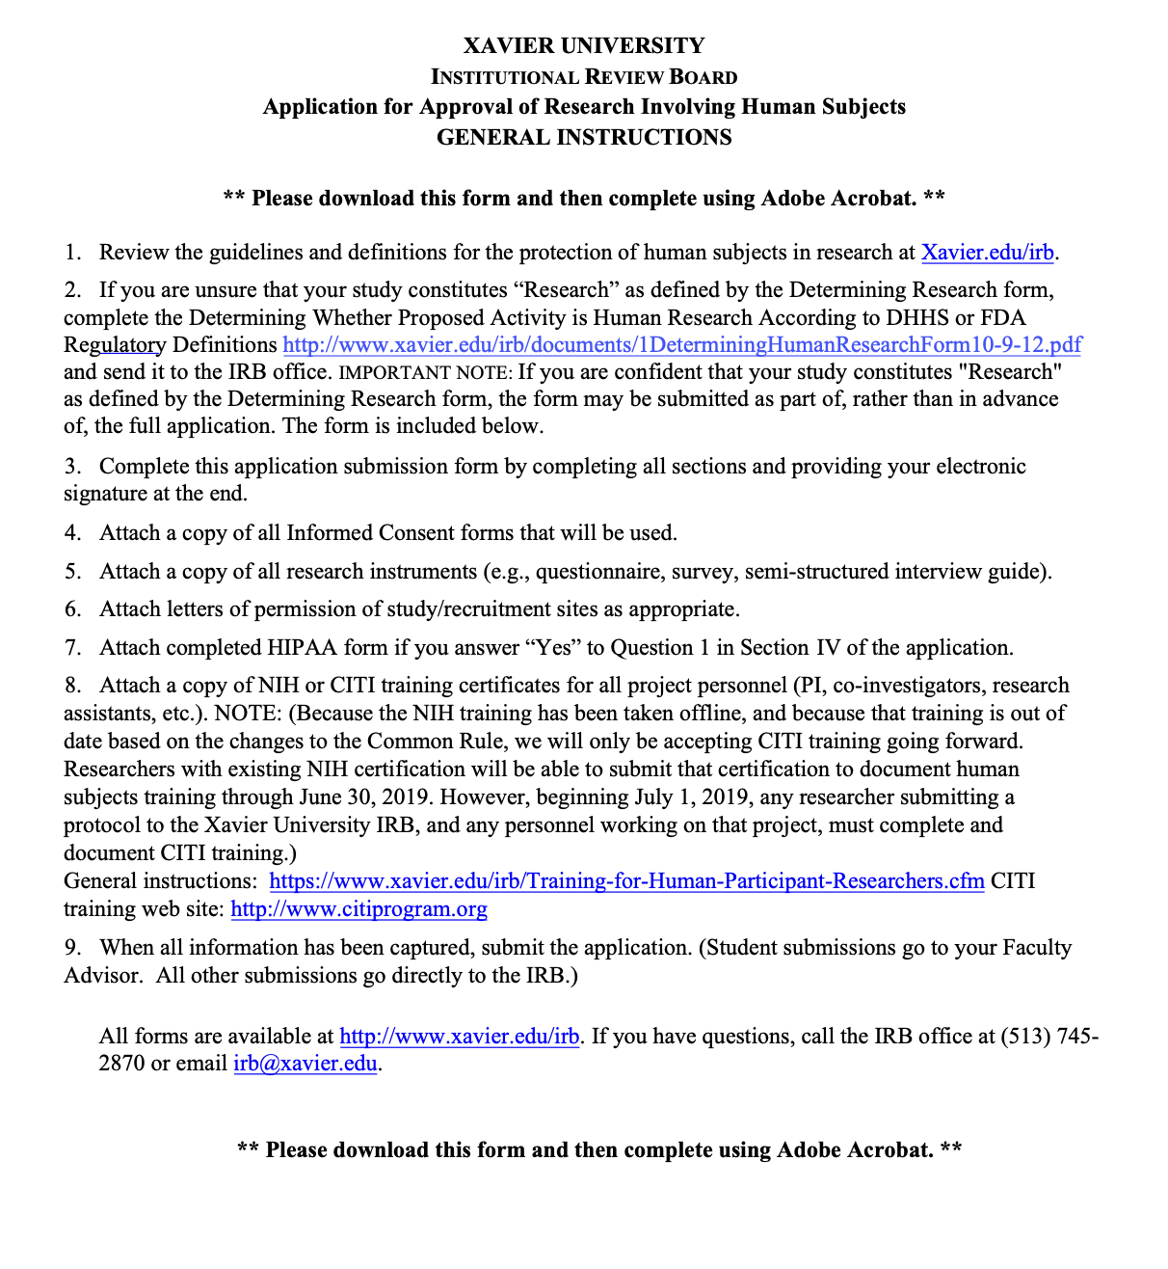

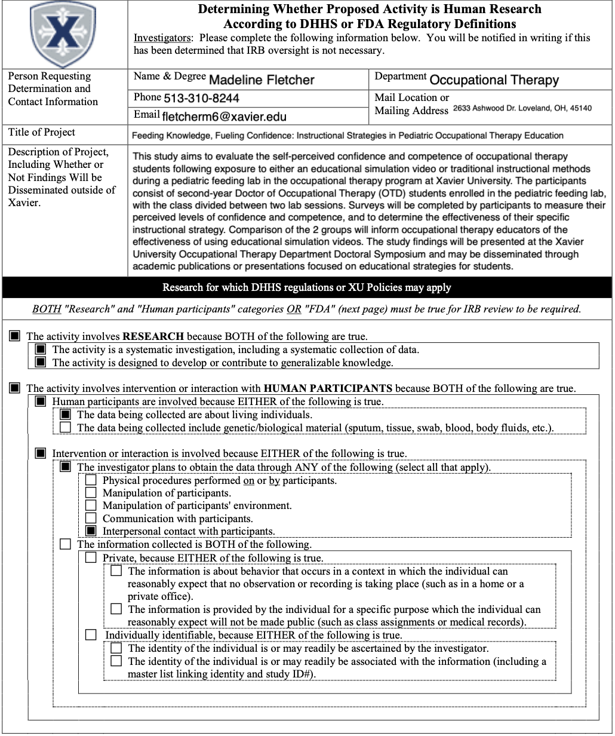

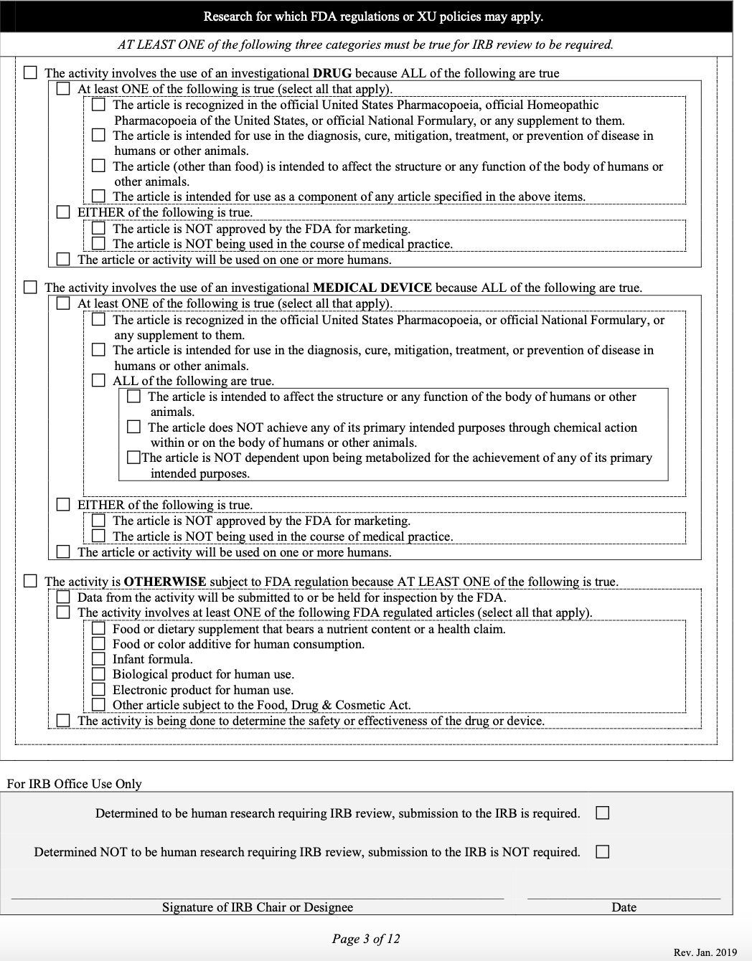

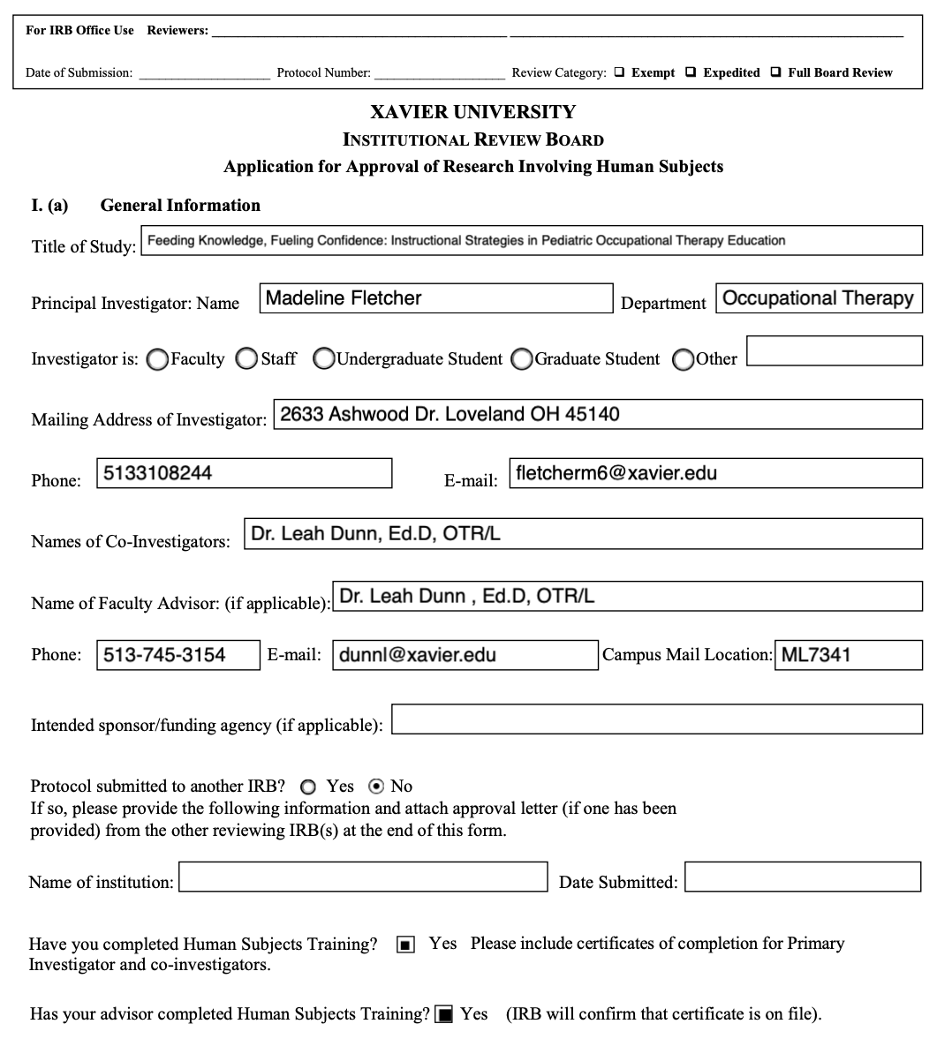

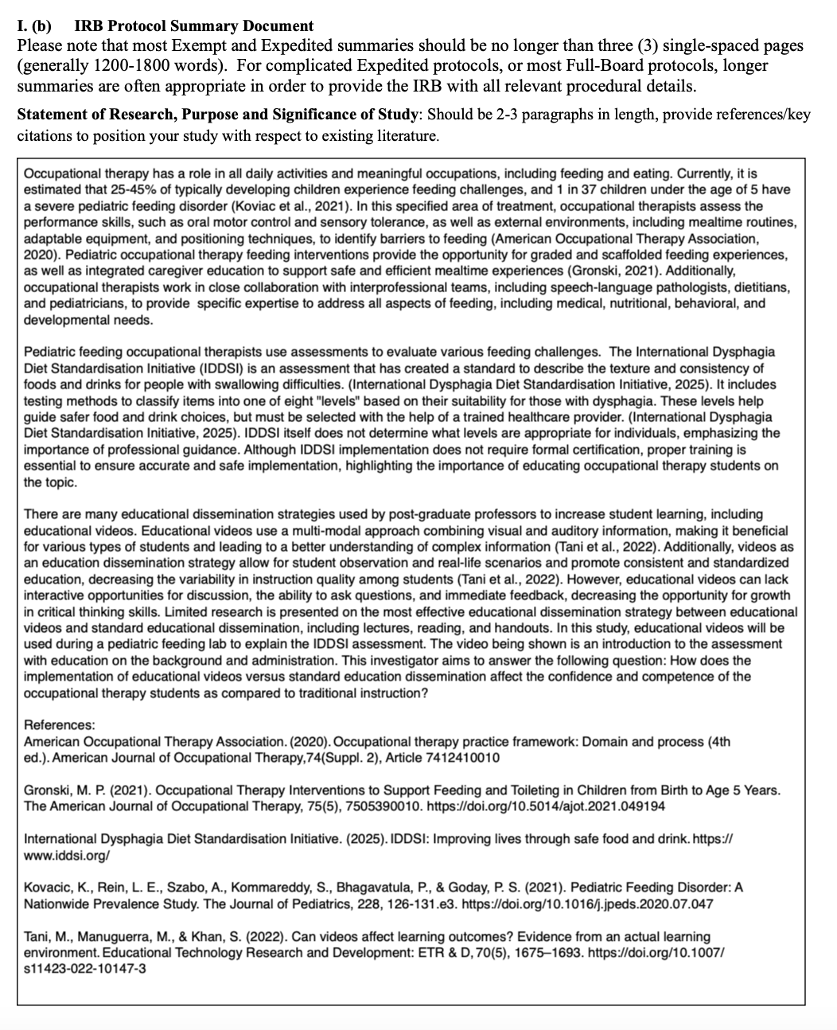

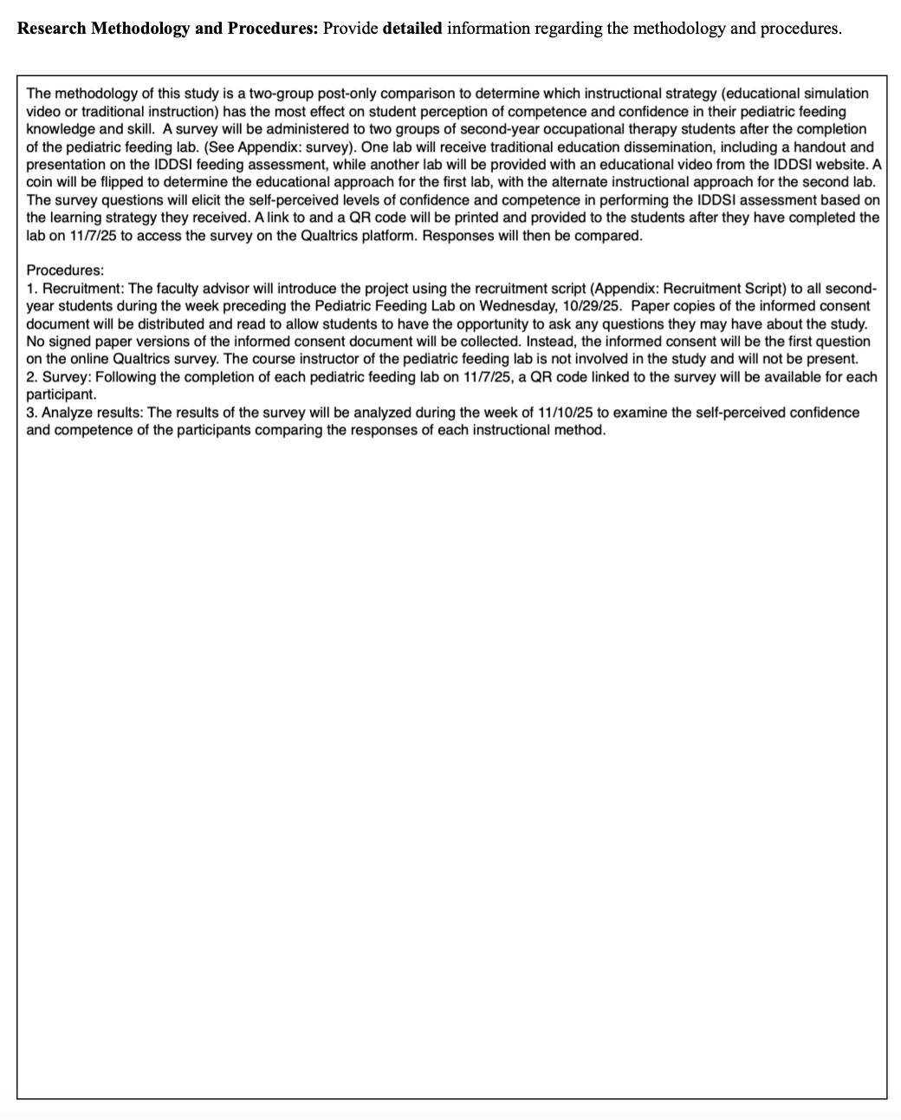

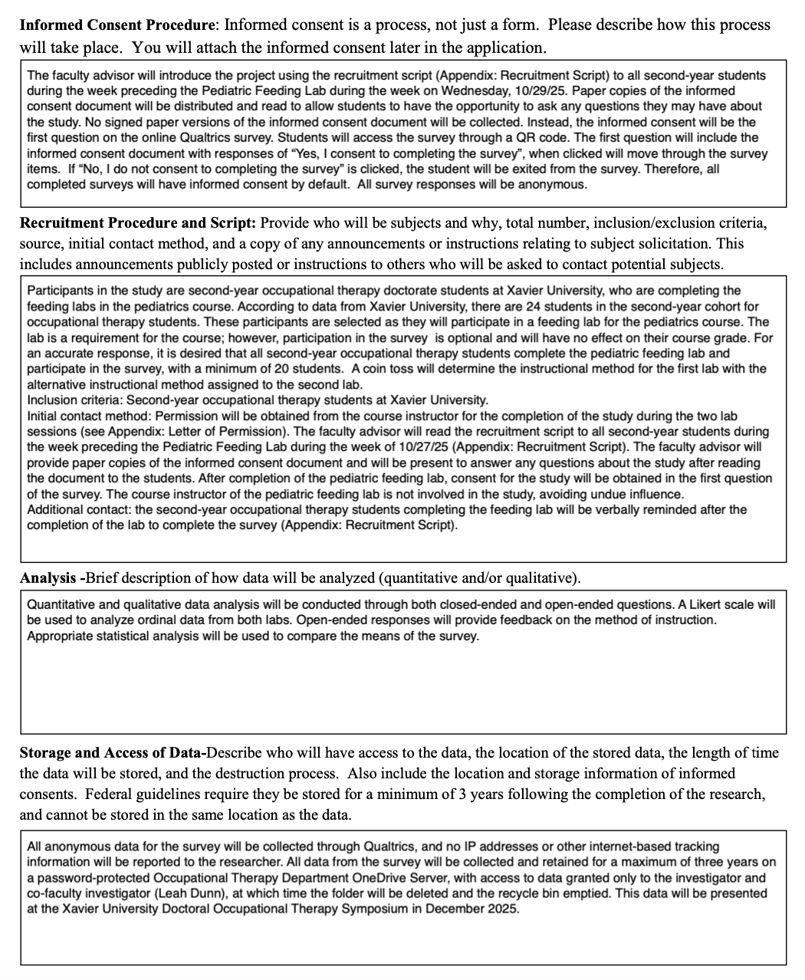

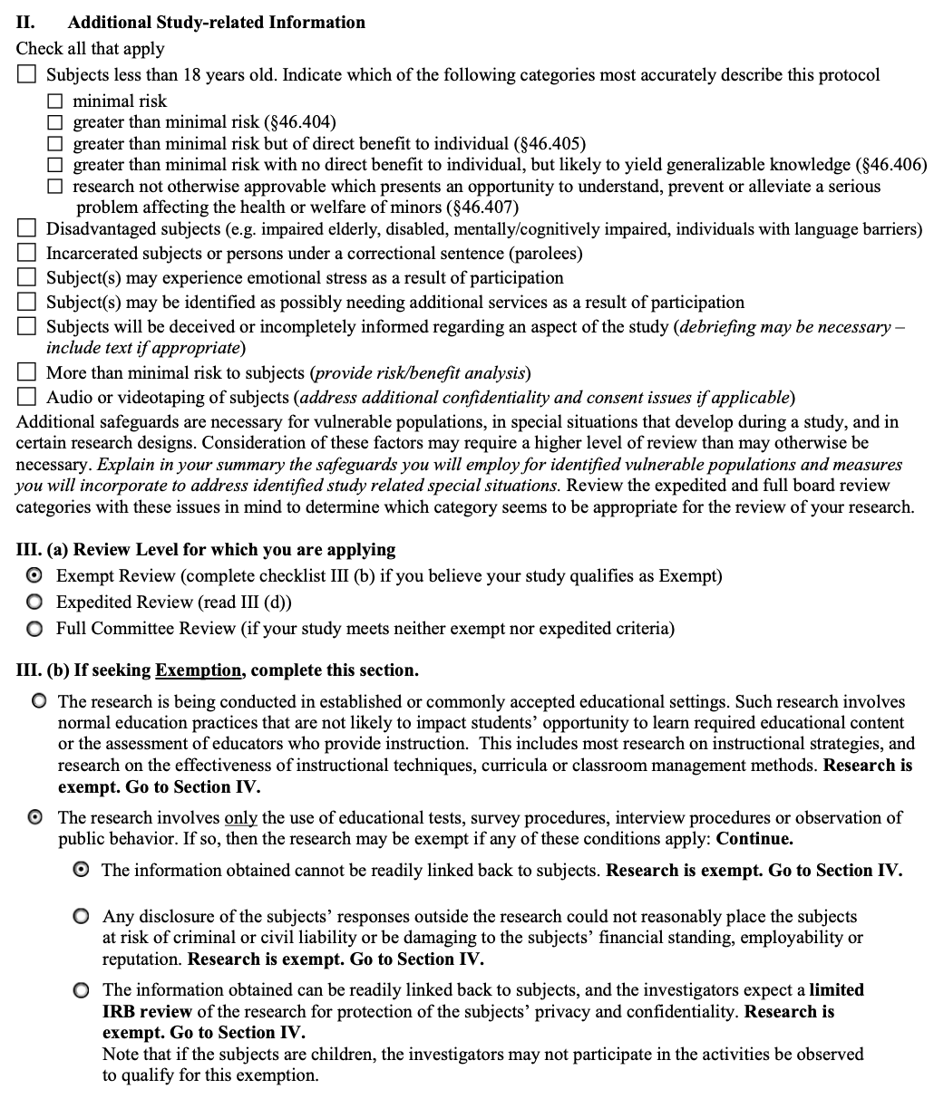

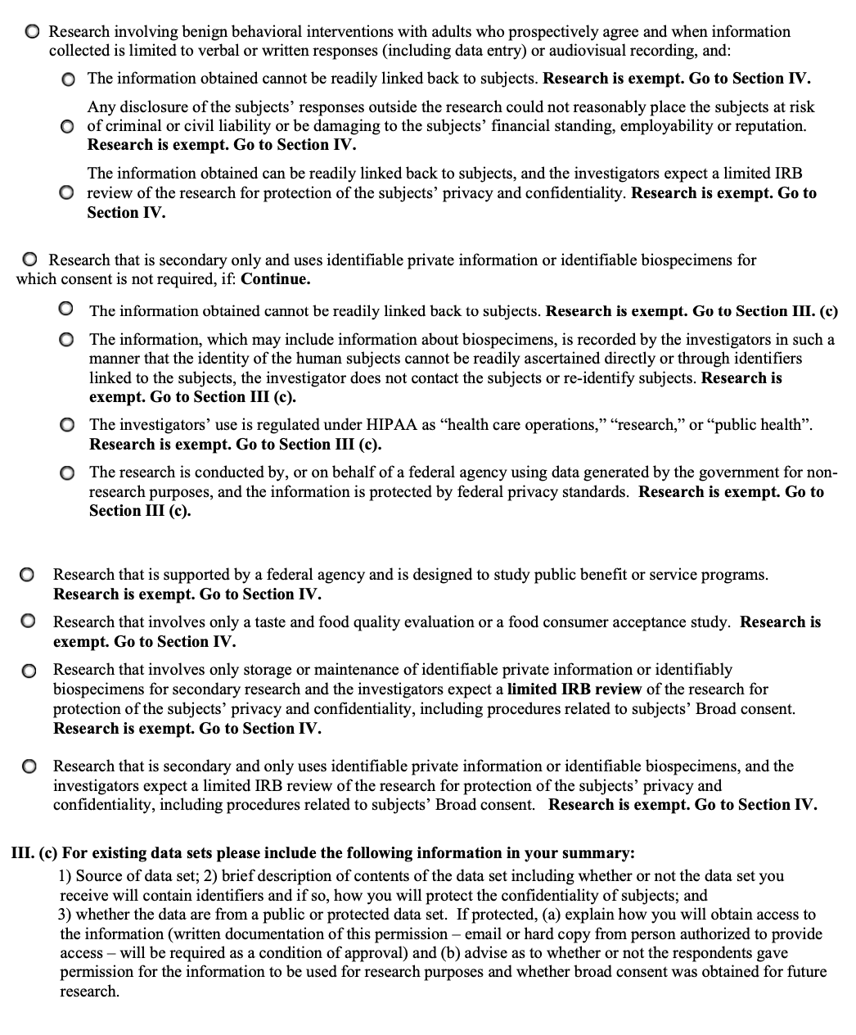

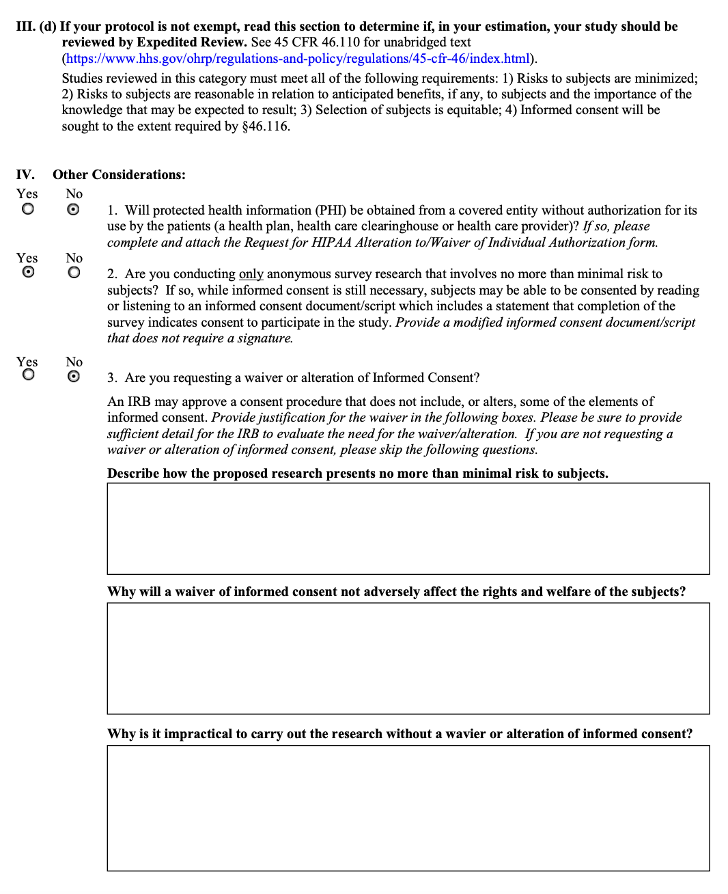

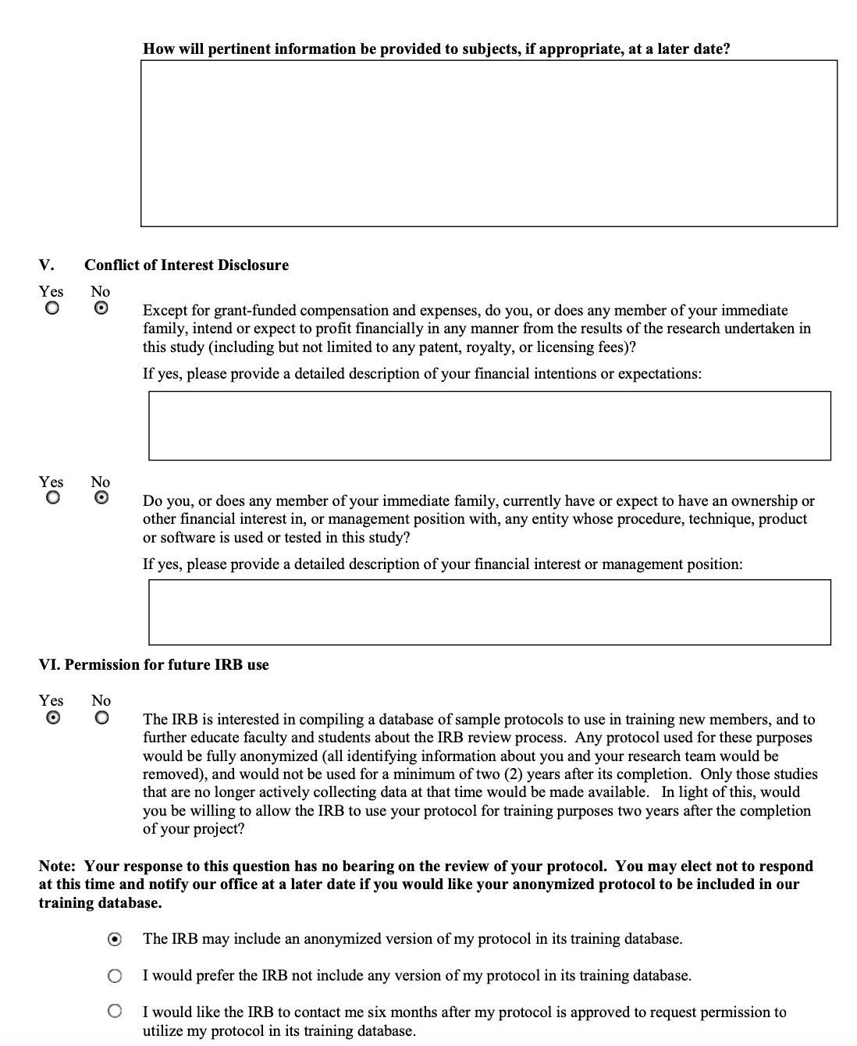

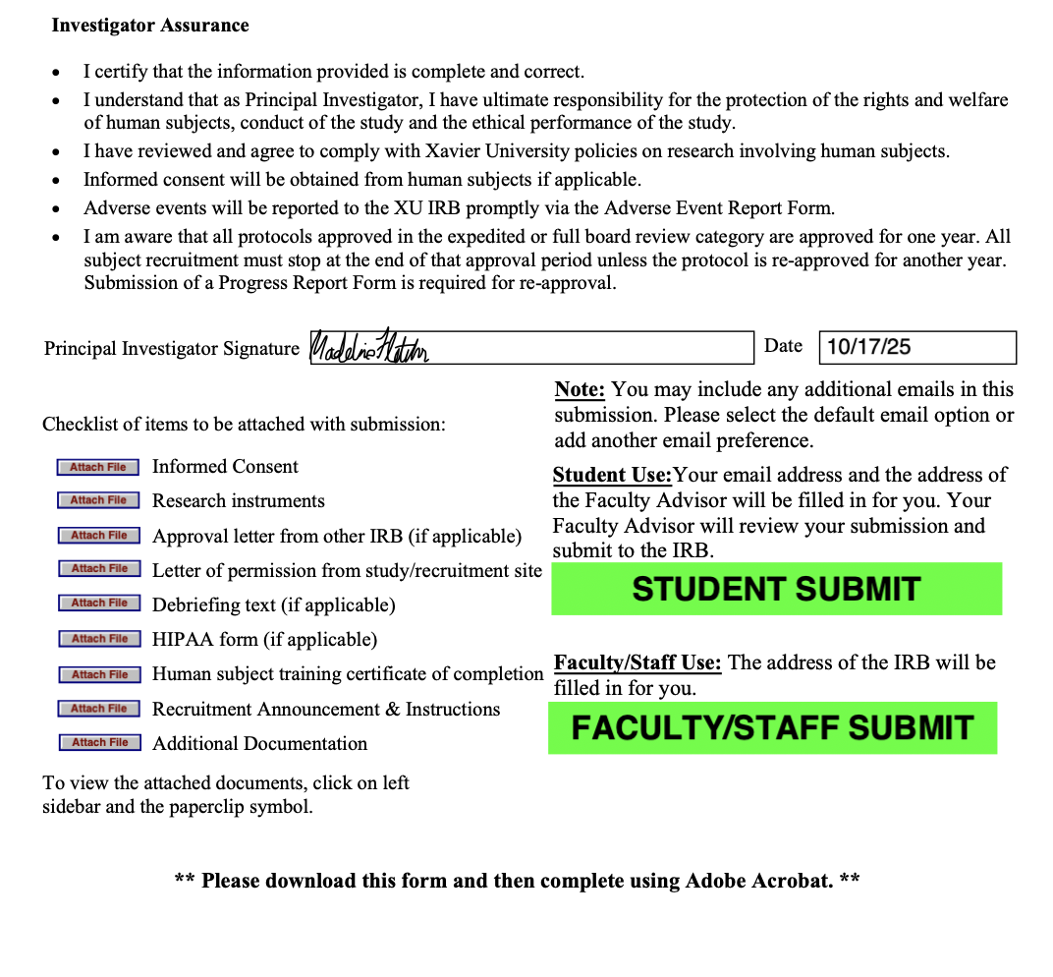

Appendix E: Capstone Goals and Objectives for a Capstone Project Table and a Capstone Experience Table
Goal# | Learning Goal | Activities to Achieve Goal | Proposed Timeline for Meeting Goal | Proposed Evidence of achieving Learning Goal
1 | Practice: Demonstrate effective communication skills and work interprofessionally with those who receive and provide care/services. | - Email experienced therapists to participate in semi-structured interview to increase outcomes for new feeding therapists.  - Assist in the co-treatment of 3 patients with a physical or speech therapist. | - Participants will be emailed on 9/1  - 11/24/25 | - Completion of semi-structured interviews  - Data retrieval from sessions
2 | Ethics: Display positive interpersonal skills and insight into one’s professional behaviors to accurately appraise one’s professional disposition strengths and areas for improvement. | - Schedule a meeting with capstone mentor halfway through the capstone program to address areas of improvement.  - Schedule a meeting with capstone mentor at the end of the program to address strengths and areas of improvement in professional behavior. | - 10/6/25  - 11/24/25 | - Email of scheduled meeting  - Email of scheduled meeting
3 | Advocacy: Exhibit the ability to practice educative roles for consumers, peers, students, interprofessionals and others. | - Complete handout for therapists to use explaining the benefit of OT in feeding  - Present to pediatric lab at Xavier about feeding | - 10/13/25  - 11/25/25 | - Completion of handout  - Completion of powerpoint presentation
4 | Leadership: Develop essential knowledge and skills to contribute to the advancement of occupational therapy through scholarly activities. | - Initiate interview through email with experienced therapists to gather data in the feeding program  - Attend interdisciplinary meeting and explain status of 1 patient . | - 9/8/25  - 11/24/25 | - Data from semi-structured interview  - Data given to capstone mentor from meeting
5 | Scholarship: Apply a critical foundation of evidence based professional knowledge, skills, and attitudes. | - Find 3 evidence based articles emphasizing the need for the videos to assist in recruitment for pre/post-survey  - Find 3 evidence based articles on new feeding interventions | - 9/1/25  - 11/24/25 | - Provide articles to new feeding therapists  - Provide articles to capstone mentor
6 | Individual Student Learning Goal: Increase levels of confidence throughout the end of the capstone experience | - Provide independent treatment for 3 clients.  - Self-rating prior to capstone and after capstone on levels of confidence | - 11/24/25  - 8/18/25 and 11/24/25 | - Anonymous data gathered from treatment session  - Self-rating form
7 | Individual Student Learning Goal: Increase levels of knowledge about feeding | - Learn how to provide 5 different feeding interventions  - Learn about 5 new feeding disorders and complications | - 11/24/25  - 11/24/25 | - Write down and give to capstone mentor  - Write down and give to capstone mentor

Goal# | Project Goal | Activities | Proposed Timeline for Meeting Goal | Proposed Evidence of Achievement
1 | Student will improve entry level therapist competency in 2 topics | 1. Student will interview experienced therapist on topics that new therapists typically struggle with  2. Student will create a pre and post test to measure level of competency in new therapist before and after educational videos. | - Semi-structure interview conducted by 9/8/25  - Pre-survey conducted by 9/15 and post-survey conducted by 11/10 | IRB approval of semi-structured interview and pre-post survey
2 | Student will determine 2 educational topics needed for new therapists | 1. A semi-structured interview will be conducted with experienced therapists on what feeding interventions are necessary for new therapists to know  2. Student will shadow 5 feeding sessions to observe specific components to a feeding therapy session. | - Semi-structure interview conducted by 9/8/25  - 11/24/25 | IRB approval of semi-structured interview and signed document from shadowed therapists
3 | Student will complete 3 educational intervention demonstration videos for new feeding therapists to view in preparation for their feeding competency. | - Student will make a trial video to understand how to use the video software  - Student will record 3 different interventions to be used in educational videos. | - Trial video completed by 10/13/25  - All 3 educational videos completed by 10/27/25 | The completion of 1 trial video and 3 education intervention demonstration videos.

Appendix F: Signed Memorandum of Understanding
Capstone Student Name  Madeline Fletcher | Capstone Site Mentor Name  Krystin Turner
Email Address  Fletcherm6@xavier.edu | Title/Position  Occupational Therapist II
Phone Number  513-310-8244 | Email Address  krystin.turner@cchmc.org
Address  2633 Ashwood Dr. Loveland, OH, 45140 | Phone Number  859-638-3714
Site Information
Name  Cincinnati Children’s Hospital | Alternate Contact Name/ Position  Karen Harpster
Phone Number  513-636-4200 | Phone Number  513-636-3200
Address  3333 Burnet Ave, Cincinnati, OH 45229 | Email Address  Karen.harpster@cchmc.org

Memorandum of Understanding (MOU), effective 8/18/2025- December 5, 2025 by and between above named doctoral student, Capstone Site, Capstone Site Mentor, and the Department of Occupational Therapy at Xavier University. The following lists the individualized Learning Objectives for Madeline Fletcher (student), the Mentoring Plan, and the Responsibilities of all Parties involved.
Learning Objectives
XU Doctoral Capstone Learning Objectives
- Practice: Demonstrate effective communication skills and work interprofessionally with those who receive and provide care/services.
- Ethics: Display positive interpersonal skills and insight into one’s professional behaviors to accurately appraise one’s professional disposition strengths and areas for improvement.
- Advocacy: Exhibit the ability to practice educative roles for consumers, peers, students, interprofessionals, and others.
- Leadership: Develop essential knowledge and skills to contribute to the advancement of occupational therapy through scholarly activities.
- Scholarship: Apply a critical foundation of evidence-based professional knowledge, skills, and attitudes.
Individualized Student-Centered Learning Objectives
- Increase levels of confidence throughout the end of the capstone experience
- Increase levels of knowledge about feeding

Project Outcomes
- Student will improve entry-level therapist competency in 2 topics.
- Student will determine 2 educational topics needed for new therapists.
- Student will complete 3 educational demonstration videos for new feeding therapists to view in preparation for their feeding competency.
Plans for Mentoring
Capstone student and Site Mentor plan to meet at Cincinnati Children’s Hospital twice a week. Student will maintain a detailed record of all mentoring meetings.
Responsibilities of All Parties
Student is Responsible for:
- Working collaboratively with the Doctoral Capstone Coordinator, Site, and Faculty Mentor to create specific learning objectives for the doctoral capstone experience.
- Working collaboratively with the Doctoral Capstone Coordinator, Site, and Faculty Mentor to create specific project outcomes for the doctoral capstone project.
- Adhering to all policies and procedures of the facility unless exempted, including prompt notification of student absences.
- Fulfilling all duties and assignments as specified by the Capstone Site Mentor, unless exempted, within the time limit specified.
- Completing 14 weeks of full-time doctoral experience. Absences must be made up to ensure 14 weeks of full-time doctoral experience.
- Evaluating the Capstone Site Mentor and Capstone Site to help continue to improve educational outcomes.
- Writing a letter of appreciation to the Site Supervisor and the Capstone Site Mentor for the educational opportunities offered to the student.
- Comply with all policies, procedures, and requirements in the Xavier University Occupational Therapy Doctoral Capstone Manual.
Capstone Faculty Mentor is Responsible for:
- Advising the student on possible practice settings for the doctoral experience.
- Mentoring the student in reviewing evidence, assessments, and interventions relevant to the selected doctoral experience area.
- Making periodic contact with the student.
Capstone Coordinator is Responsible for:
- Ensure that a signed MOU is in place for the capstone site, focusing on a student’s topic of interest.
- Mentoring and orienting students to the general purposes of the doctoral experience and project and providing them with needed forms.
- Making periodic contact with the student as needed.
- If necessary, develop and implement a policy for withdrawing students from a doctoral experience.
- Reassigning students who are not successful in the doctoral experience in accordance with policies and procedures in the Xavier University Occupational Therapy Doctoral Capstone Manual.
Capstone Site Mentor is Responsible for:
- Collaborating with the student and Doctoral Capstone Coordinator in the development of the doctoral experience learning objectives that provide opportunities for the practical implementation of theoretical concepts offered previously during the Occupational Therapy Doctoral program at Xavier University.
- Evaluating each student at the midpoint and conclusion of the doctoral experience using the Learning Objectives and Project Outcomes listed above. The Site Mentor will be provided with the evaluation form.
- Collaborating with the student, Xavier University Capstone Coordinator, and Institution to ensure success and address concerns as they arise.
- Being familiar with the policy regarding the "withdrawal of students from doctoral experience" for Xavier University.
- Providing student mentoring meetings as outlined and additional as indicated.
Ownership of Work Product
X Materials developed for the site (i.e. handouts, program protocols) by the student are exclusively the property of the site.
OR

- Materials for developed for the site (i.e. handouts, program protocols) by the student are co-owned by the capstone student and Capstone Site and therefore can be used by both parties in the future without additional consent.
Authorship
- Authorship Not Applicable
- Memorandum of Understanding Addendum A

By signing the agreement, all parties agree to the provisions above.
Madeline Fletcher S/OT 12/1/2024
Student Date

Marnie Renda OTD, OTR/L 12/2/24
Doctoral Capstone Coordinator Date

Krystin Turner, DHSc, OTR/L, SCFES 12/8/24
Capstone Faculty Mentor Date
Cincinnati Children’s Hospital and medical center 12/8/24
Capstone Site Date

Appendix G: IRB Letter of Response

Appendix H: Week-by-Week Project Plan

P= Project Goal
L= Learning Goal

Week | Activities | Related Goal | Progress/Status at end of week
1  8/18 | Orientation/Observation  - Data gathering in feeding therapy sessions  - Emailing experienced therapist semi-structured interviews  - Initial confidence self-rating form | P1.1  P2.1  P2.2  L1.1  L4.1  L6.2
2  8/25 | Orientation/Observation  - Data gathering in feeding therapy sessions  - Completing experienced therapist semi-structured interviews | P1.1  P2.1  P2.2
3  9/1 | Orientation/Observation  - Analyze results from semi-structured interview  - Emailing new feeding therapists in the feeding competency program to complete pre-observation video survey  - Delivery model investigation – starting to understand how to make videos  - Parent permission for children that are going to be in the video | P1.1  P1.2  P2.2  L5.1
4  9/8 | Project Preparation  - Training for video designing using a storyboard method  - Implement pre-survey for feeding therapists | P1.2  P2.2  L5.1
5  9/15 | Project Preparation  - Decide on content that will be used in the videos  - Scheduling for video taping  - Videotaping therapy sessions | P3.1  P3.2
6  9/22 | Project Implementation  - Scheduling for video taping  - Videotaping therapy sessions | P3.1  P3.2
7  9/29 | Project Implementation  - Scheduling for video taping  - Videotaping therapy sessions  - Meeting with capstone mentor regarding professional behavior | P3.1  P3.2  L2.2
8  10/6 | Project Implementation  - Editing recorded videos for trial education video  - Complete handout on benefit of OT in feeding | P3.1  L3.1
9  10/13 | Project Implementation  - Editing recorded videos for first education video | P3.2
10  10/20 | Project Implementation  - Editing recorded videos for second and third education video  - Present to pediatric lab at Xavier about OT in feeding | P3.2  L3.2
11  10/27 | Project Implementation  - Scheduling for new therapists to view the educational videos  - Viewing of videos for educational therapists  - Email therapists to complete post-viewing survey | P1.2  P3.2  L5.1
12  11/3 | Project Implementation  - Scheduling for new therapists to view the educational videos  - Viewing of videos for educational therapists  - Therapists complete post-viewing survey | P1.2  P3.2

